Batch: B1 Roll No.: 1611077

Experiment No. ___5____

Grade: AA / AB / BB / BC / CC / CD /DD

Signature of the Staff In-charge with date

Title: Implementation of Single source shortest path by Greedy strategy

Objective: To learn the Greedy strategy of solving the problems for different types of problems

CO to be achieved:

Sr. No | Objective
CO 1 | Compare and demonstrate the efficiency of algorithms using asymptotic complexity notations.
CO 2 | Analyze and solve problems for divide and conquer strategy, greedy method, dynamic programming approach and backtracking and branch & bound policies.
CO 3 | Analyze and solve problems for different string matching algorithms.

Books/ Journals/ Websites referred:
- 1. Ellis horowitz, Sarataj Sahni, S.Rajsekaran,” Fundamentals of computer algorithm”, University Press
- T.H.Cormen ,C.E.Leiserson,R.L.Rivest and C.Stein,” Introduction to algortihtms”,2nd Edition ,MIT press/McGraw Hill,2001
- https://www.mpi-inf.mpg.de/~mehlhorn/ftp/ShortestPathSeparator.pdf
- en.wikipedia.org/wiki/Shortest_path_problem
- www.cs.princeton.edu/~rs/AlgsDS07/15ShortestPaths.pdf

Pre Lab/ Prior Concepts:
Data structures, Concepts of algorithm analysis

Historical Profile:
Sometimes the problems have more than one solution. With the size of the problem, every time it’s not feasible to solve all the alternative solutions and choose a better one. The greedy algorithm aim at choosing a greedy strategy as solutioning method and proves how the greedy solution is better one.
Though greedy algorithms do not guarantee optimal solution, they generally give a better and feasible solution.

The path finding algorithms work on graphs as input and represent various problems in the real world.

New Concepts to be learned:
Application of algorithmic design strategy to any problem, Greedy method of problem solving Vs other methods of problem solving, optimality of the solution

Algorithm:

Example Graph :

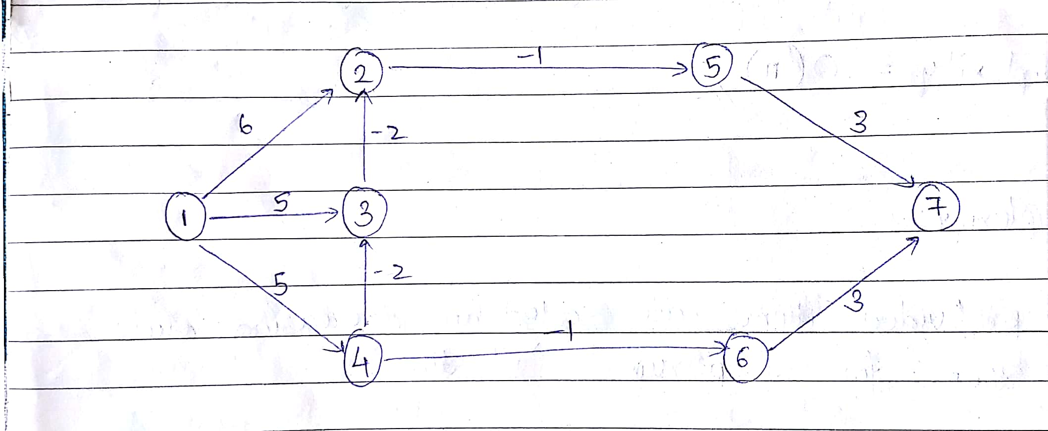

Solution:

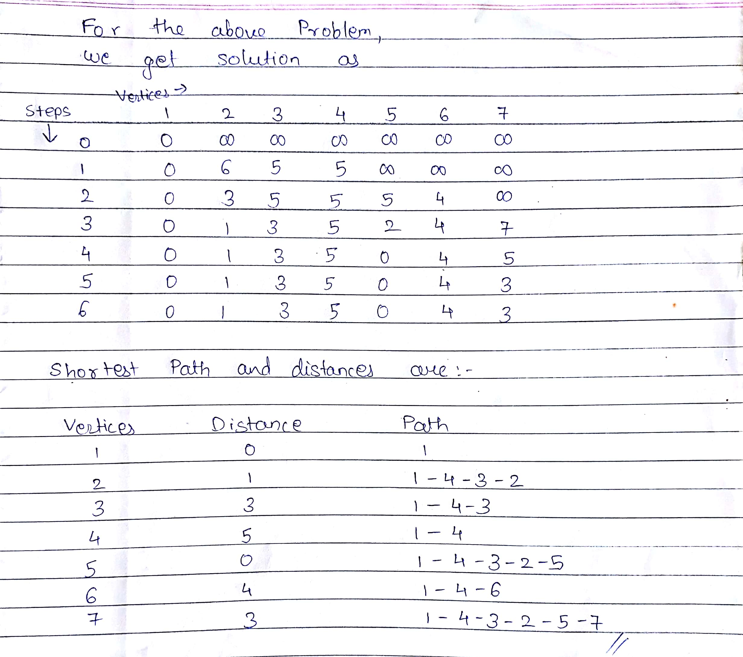
Time Complexity for single source shortest path:

Algorithm:
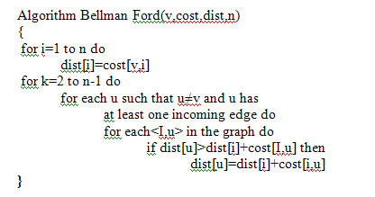

- Here we can see outer loop runs n times i.e. V times i.e. no. of Vertices
- Inner loop runs E times i.e. no. of edges
- Therefore Time Complexity of the algorithm is O(VE).

IMPLEMENTATION:

import java.util.*;

public class Bell
{
public static void main(String[] args)
{
Scanner sc=new Scanner (System.in);
System.out.println("Enter the no. of nodes: ");
int n=sc.nextInt();
System.out.println("Enter the no. of edges: ");
int e=sc.nextInt();
int a[][]=new int[n][];
int b[][]=new int[n-1][];
int i,j,k,l;
System.out.println("Enter the edges: ");
for(i=0;i<n;i++)
{
a[i]=new int[n];
}
for(i=0;i<e;i++)
{
a[sc.nextInt()-1][sc.nextInt()-1]=sc.nextInt();
}
for(i=0;i<n;i++)
{
for(j=0;j<n;j++)
{
if(a[i][j]==0&&i!=j)
{
a[i][j]=999;
}
}
}
System.out.println("\nThe adjacency matrix is: ");
for(i=0;i<n;i++)
{
for(j=0;j<n;j++)
{
System.out.print(a[i][j] + " ");
}
System.out.print("\n");
}
for(i=0;i<n-1;i++)
{
b[i]=new int[n];
}
for(i=0;i<n;i++)
{
b[0][i]=a[0][i];
}
System.out.print("\n\nTABLE: \n");
for(l=0;l<n;l++)
{
System.out.print(b[0][l]+" ");
}
int temp[]=new int[n];
int t,t2=0,f;
for(i=1;i<n-1;i++)
{
for(j=0;j<n;j++)
{
t=b[i-1][j];
for(k=0;k<n;k++)
{
temp[k]=b[i-1][k]+a[k][j];
if(k==0)
{
t2=temp[k];
}
else if(k>0&&temp[k]<t2)
{
t2=temp[k];
}
}
f=Math.min(t,t2);
b[i][j]=f;
}
System.out.print("\n");
for(l=0;l<n;l++)
{
System.out.print(b[i][l]+" ");
}
}
System.out.println("\n\nProgram by Mihir Gandhi B1 1611077");
}
}

OUTPUT:

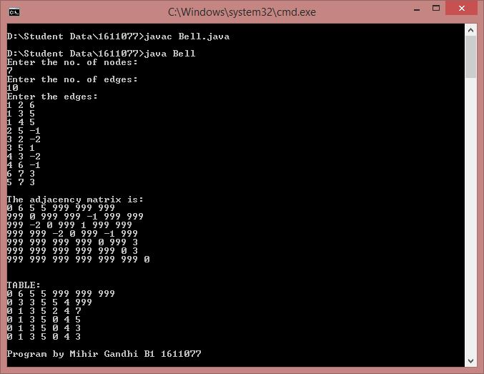

CONCLUSION:

Thus, implementation of Single source shortest path by Greedy strategy in the form of Bellman Ford algorithm. The actual outcome matched with the expected outcome.

